Reality Labs & AI Partnerships CRM

We are excited to announce the launch of a new CRM application built on Salesforce for the Reality Labs & AI Partnerships team. The Llama team within RL & AI Partnerships is the first to use the new app and we plan to extend it to other teams over the year. The CRM App is essential for Meta to accomplish the goal of growing the AI Partnership ecosystem and primarily the growth in Enterprise adoption of Llama.

Meta is growing our Llama partnerships from a few dozen to hundreds this year and the teams managing these partners are growing. The previous g-sheet tracker does not scale or provide the functionality needed for this explosive growth. Winning for LlamaX is about maximizing developer adoption where we can drive faster feedback loops to make Meta’s AI platform better. Meta will work with partners to help meet these goals and the CRM app will be key to ensuring Meta’s teams are aligned and focused on the most important opportunities.

For more background, Mark Zuckerberg provided an overview for Meta’s place in AI here or checkout the LlamaX Feedback group here.

Cc: Nico Clemminck, Stephanie Chen

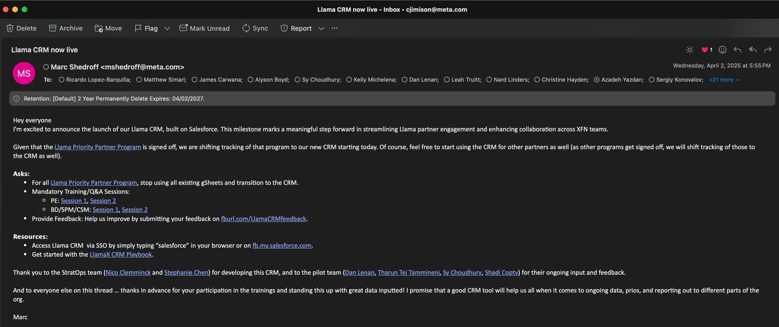

Goal of this sub-task: -->Built automations around the New Object { Llama Opportunity Checklist} & its Fields

Summary of Automations:

Restrict users from leaving "1. Internal Identification" Stage without creating the Llama Opportunity Checklist record

Once on the Llama Opportunity Checklist record, make sure users fill out the mandatory Status fields.

Automate the Llama Opportunity Checklist's record Name (users need not fill it manually,)

Restrict users from creating another record for Llama Opportunity Checklist, only one record could exists per opportunity.

Restrict users from leaving "1. Internal Identification" Stage without filling the Llama Checklist Field 'Meta to Reach out'

Make users fill out the 'Partner Exploration' section of Llama Checklist obj before moving onto the next stage.

Make users complete the 'Technical Evaluation' section of llama Checklist before moving onto the next stage

Make users complete the 'Production/Closed' section of llama Checklist before moving onto the next stage

The Reality Labs & AI Partnerships has a checklist of 15-20 milestones that they expect to complete for each opportunity. These checklist items need to be included on their Opportunity reports to show the progress and if any blockers are identified.

Rather than adding a new fields on the Opportunity object for each Milestone Checklist item, there will be a parent-child relationship between the Opportunity record and a "Checklist" object record where the 15-20 milestone checklist items will exist. There will be a flow that creates the "Checklist" record for each Llama opportunity record type.

This task is to create a visual component that can be added to the Details page on the Llama Opportunity record type page where all of the checkiist fields are visible and can be edited. The experience for the user should all be within the opportunity and no need to navigate to the related "checklist" object.

Trigger to create a new Opportunity_Checklist__c records for each newly created Opportunity with a "LlamaX" record type (RecordTypeID = 012Kj000001HYRMIA4) NOTE: Should be 1:1 relationship between Opportunity and Opportunity_checklist__c records.

Lightning Component for viewing editing Checklist record directly from Opportunity page. (could be it's own tab if needed).

RL&AI Partnerships: Capture Last Activity Date on Opportunity

Opportunity ID Equals Geet Related Llama Opportunity > Opportunity ID

Account ID Equals {!$Record.AccountId} Triggering Opportunity > Account ID

Triggring Opportunity > Account ID > Open Llama Opportunites equals False

Default Outcome

Example of Scheduled Flow Below:

LlamaX Identify Stale Opportunities

varOpportunityToSendNotificatin > Owner ID

varOpportunityToSendNotificatin > Opportunity ID